Publicity is the very soul of justice.
—Jeremy Bentham, Philosopher

A disturbing story from the disability not-for-profit sector
Michael Cole
Background
THE CEO of a disability not-for-profit association recruited me onto the board. Most of the members of the organisation, North West Disability Service (NWDS), were long-term friends and supporters of the CEO. Parents of service users were not encouraged to become members. Furthermore, the available application form was non-compliant with the NWDS Constitution in not having space for the signatures of two members who personally knew the applicant. That allowed the board to reject unwanted applicants as “not known to us.”

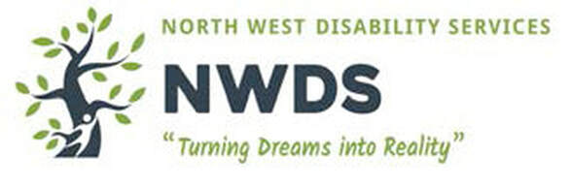
Five previous board members left the board after opposing the CEO. The CEO refused, contrary to the NWDS policies, to allow the board to address several senior staff complaints about being bullied by the CEO.
The association was constituted to benefit the disabled, with priority for those in our Local Government Area (LGA).
Speaking up
I expressed concern about the millions of dollars spent in a distant LGA, while there was no visible progress in our LGA where 95% of users lived, and concern that local parents were being misinformed.
​The CEO claimed I had assaulted her. She claimed the assault was “clearly seen” by two witnesses, required medical attention and that she had reported this assault, and another, to police and obtained incident numbers.

An independent investigation found that the alleged witnesses did not report seeing anything. The CEO could not supply any medical substantiation. NSW police advised that the CEO had made no reports, so there were no incident numbers.
The investigation rejected the CEO's' claims and found the CEO’s behaviour was a dereliction of duty and that she was failing her job description, and the board lacked understanding of governance.
In spite of the independent investigator’s findings, the CEO continued to claim that everything she had said was true. Nearly all the board members rejected the external investigation. After they were re-elected at the next annual general meeting, I was expelled from the association.
​
​Another board member became concerned about reports about bullying of senior staff by the CEO and the lack of action by the board. He attempted to investigate but was detected by the CEO and accused by the board of divulging confidential information. However, no evidence supporting this accusation was provided. He left the board.
Another board member (BM) had an intellectual disability and was supported at board meetings by his father. He did not attend one board
meeting but gave his written proxy to the secretary. Another board member falsely claimed to have BM’s proxy and together with the CEO removed BM from a social event and induced him, in the absence of his father, to vote opposite to his actual intentions.
I have documentation to support all the statements in this article.

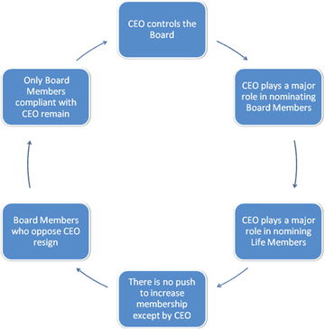
​Regulatory capture
Regulatory capture is where the entities being regulated get control of the regulator, for example, developers getting control of the Council.
​
Few of the board members seemed to know much about governance, and the constitution, codes and policies were repeatedly breached. Some had children with difficult behaviours that were being accommodated by the CEO. It appeared that the CEO arranged for the appointment of most board members and new members (using the correct form), and dictated all policy and direction.

Board members who displeased her ended up leaving.
​The regulator
Responding to a complaint, NSW Fair Trading said no law under the Incorporation of Associations Act (NSW) had been breached.
​NWDS is funded ultimately by NDIS and NDIA.

​Conclusion
The case study illustrates how influence can be exerted within a not-for-profit organisation, how accountability can be avoided, and the futility of
reporting problems to the current regulators.
Michael Cole is vice president of Whistleblowers Australia.

Read the original article in The Whistle.

https://www.bmartin.cc/dissent/contacts/au_wba/whistle201904.pdf
​Home
Become a member of North West Disability Service
Contact us. Tell us what you know
Resources and Help (for bullying and reprisals)

